Hiding Data in Digital Image using Steganography and Applied Encryption

¹Madhuri Sharma ²Anshuman Jha, ³Kamlesh Chag, ⁴Aakashdeep Ghosh, ⁵Aman Sharma
SRM Institute of Science and Technology, NCR Campus, Modinagar, Ghaziabad
madhurisharma44@gmail.com anshuman_jha@outlook.com chag.kamlesh@gmail.com
aakashonmoney@gmail.com aman.axel@gmail.com

Abstract—In this paper we show a new approach for data hiding inside digital image which uses the LSB based algorithm for hiding information in cover image this is called as Steganography and applying Partitioning, Bit Swapping, Zigzag Rule and Binary Conversion which is a part of our Encryption phase. Our approach also has a user authentication feature with the help of which only genuine intended users will be able to act as sender and receiver thus any kind of forgery is prevented. Use of more than one key and security mechanism make this approach better than traditional with high PSNR value and low MSE. One distinct feature that we offered was inaccessibility of both cover image and hidden image when being transferred to a Receiver via any medium.

Keywords—image hiding; information security; key; LSB; encryption;

- INTRODUCTION

With regards to the consideration of the system data security issues, the use of information security innovation has been further researched. As foundations of security system, the cryptography technique, in a specific degree, meet the part prerequisite of data security, yet today the conventional cryptography strategy is not reasonable for taking care of the issues of the multimedia aspects, keeping in mind the end goal to better take care of the issue of multimedia data security, data concealing learning emerges at the historic moment. Nowadays information hiding is widely studied and applied in fields such as Protection of intellectual property rights, content authentication, secure communication etc.

Images are one of the most important source of obtaining information from the world and hiding data in these images is one of the most studied and researched topics in the field of information security. In which LSB based algorithm that is the simplest algorithm to perform data hiding in images is one of the most researched topics due to its simple algorithm and fast encryption and ability hide large amount of data. It’s mostly used in Steganography Software.

This paper is an improved method of Steganography that uses LSB based color image Steganography algorithm and is combined with human visual characteristics (red, green and blue color), secret Keys, user authentication service, and several other cryptography algorithms to improve overall security.

- STEGANOGRAPHY AND ENCRYPTION ALGORITHMS

Steganography is a method through which we upset a Cover image by inserting a hidden text into it. This change might be visible to a human and may be not just to insure the security we use LSB based method so that the change is least visible to a human eye. A essence of cryptography is also applied to this method to make the cover image inaccessible to an intruder and improve security. This article is a cryptography and information hiding techniques combined. Below are the algorithms that have been used.

A. Least Significant Bit Method

Least significant bit (LSB) algorithm used in this paper is a spatial domain steganography in substitution method; the formula here is to replace the LSB of the cover image with the MSB of the data to be hidden. For 256 gray scale cover image, the gray scale value of each pixel can be used to represent 8-bit binary, Taking out certain bits of all pixels gets us a certain bit plane now higher the bit plane greater the contribution of gray scale lower the bit plane higher the noise is.

B. Partitioning Method
Partitioning is possible in many ways. For an example, let N = 4 bits. Using 4 bits we can partition bit sequences into 2^4 or 16 parts. Producing each part with equal no of bits. If there is m-number of bits in the data file, each partition will get the ceiling of [M/2N] number of bits. This holds down for every part except the last one. Let, the data bit is 1000 bits long. As N= 4 each partition here will have (1000/2^4 = 62.5 or) 63 bits. And thus in the last or 2Nth partition there will (1000 - 63x15) 55bits.

C. Zigzag rule
A line or course that proceeds by sharp turns in alternating directions is known as Zigzag. By this rule first bit of selected bits will be placed in right position. Again second bit will place in left and third bit will be placed in right position and so on. Here is an example of zigzag:

Let’s select two bits that are
BIT = “1010010100101011”
BIT Zigzag= [Empty]

First bit of BIT = 1
It will be placed in the right position of BIT Zigzag
So, BIT Zigzag= “1”

Second bit of BIT = 0
It will be placed in the left position of BIT Zigzag.
So, BIT Zigzag = “01”

Third bit of BIT=1
It will be placed in the right position of BIT Zigzag.
So, BIT Zigzag = “011”

Forth bit of BIT= 0
It will be placed in the left position of BIT Zigzag.
So, BIT Zigzag = “0011”

After placing all bits BIT will become BIT Zigzag = “1000110011000111”
By this procedure all bits of selected partition will be converted.

D. Swapping method
In our key first i-bit represent the value of N and remaining j-bits used for swapping. Each N number of bits from j will select the partitions for swapping. Number of swap (M) = j/N;
Let, KEY = 1000 1101 1010.
Here i = 4 so j = key-4 = 8.
So, M= 8/4 = 2 swaps.
As, N = 1000 b = 4d there will 2^4 = 16 partitions.
Then j1=1101b = 13d, so 13th partition will swap with the 1st partition.

E. Binary Conversion
The algorithms like partitioning, zigzag and swapping are to be applied in the bits of the image. For these algorithms to be implemented, the image should be converted into binary data in the first place. Hence, the process of encryption starts off with the conversion of chosen image into binary format. For this each pixel is converted into 8 bits or 1 byte.

F. Peak Signal-to-Noise Ratio

In image processing PSNR stands for peak signal-to-niose ratio. When you calculate PSNR, you will find that it has MSE term (mean square error) in the denominator. MSE estimates error. Therefore if the error is high (i.e. low quality image), then the PSNR value will be lower and if error is less (i.e. better image quality), then PSNR value will be high. Therefore, if the PSNR value is low, that means the image quality is poor.
In the calculation of PSNR, we must first calculate the Square Error Mean (MSE) between the hidden image and the cover image.

The equation is represented as below.

 | 1 | N | 2 | (1)
MSE = | 1 | ¦(c_{i} − s_{i} ) |  | (1)
 | N i=1

Ci and Si respectively represent the i pixel of the cover image and the hidden image, N for the total number of pixels. Then use the MSE to get the PSNR value of the hidden image as follows, the unit is dB:

§ | 255 | 2 | · | (2)
¨ | 255 |  | ¸ | (2)
PSNP = 10 lg¨ |  |  | ¸
© | MSE _{¹}
Generally speaking higher the PSNR better it is for us while implementing steganography since it determines how relatable our cover image and hidden data are. The quality of image is acceptable if its greater than 28db.

III. PROPOSED METHOD FOR HIDING DATA IN DIGITAL IMAGE USING STEGANOGRAPHY AND APPLIED ENCRYPTION.

We improve the randomness of the LSB based hidden text embedding into cover image and encrypt the message with control information, so that the hidden text cannot be extracted without a key. In order to eliminate chances of forgery we use a user authentication service and keys so that only a genuine user will be able to use the program. Through this encryption technology for embedding position of the random LSB, the algorithm of original LSB has greatly improved in terms of security.

We choose to hide a text in a color image, in which the size of the cover color image is small. As shown in Figure 1 
Fig. 1. The cover image and the secret image

First we enter a control text which we need to hide inside a image now this text will help us to find a particular location where this text will be embedded. Here we have chosen zhouxinyi09 as control message or hidden text. As shown in Figure 2. Control message is firstly converted into bit stream and is embedded into the cover image.
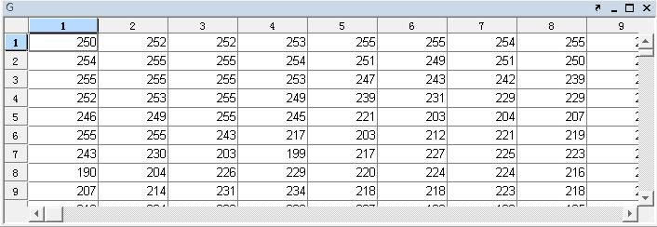
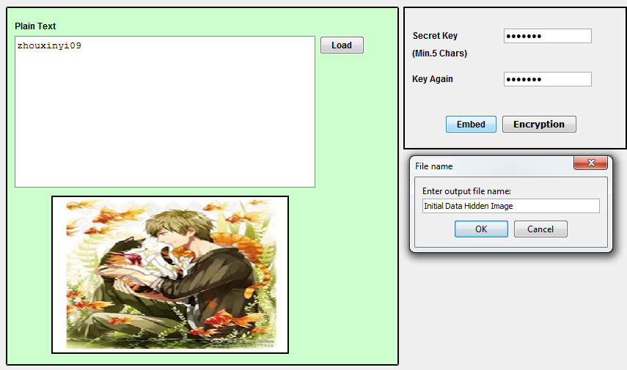
Fig 2. Hiding text in Cover Image and giving a secret key.

The sender first of all passes a user authentication or register before hiding a text or retrieving a text from image. After this the sender selects a text to be hidden and chooses a image now this Image should be small enough so that bit conversion time is less that will take place in later on stage. A key is then provided so that for reverse steganography to take place by any genuine intended receiver. This key is entered by sender that is also present with a receiver.

Here we use control information for image information hiding. A 24bit RBG color image can be divided into 3 matrix namely Red matrix, Green matrix, Green matrix. Now all these matrix are 2 dimensional matrix.
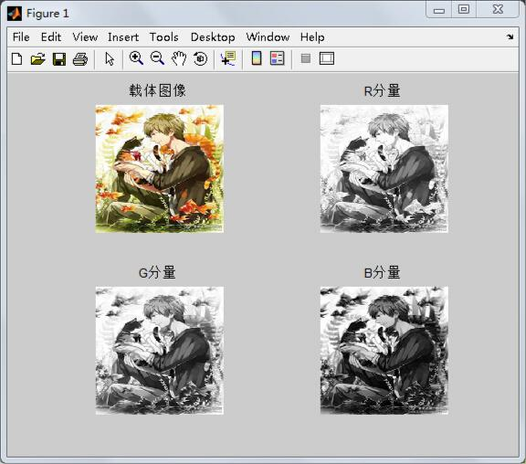

Fig. 3. The color image into the Red, Green, Blue of the three matrix

Fig. 4. Green matrix

Data of each matrix can be represented by a number between 0 and 255 and later each pixel can be represented by a 8 bit binary number. Then each component can take out the least bit from all pixels to compose the same size matrix which the value is 0 or 1, so that you have three matrix of lest bits composed from Red matrix, Green matrix and Blue matrix. Figure 5 is the matrix composed from least bits of green matrix.
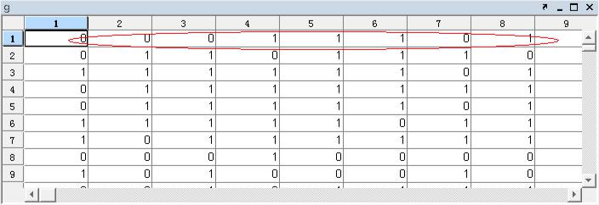

Fig. 5. the matrix composed of the least bit of G matrix

Now the text that is to be hidden (text messages or images) should be transformed into the binary bit stream, which is convenient for embedding, like figure 6.
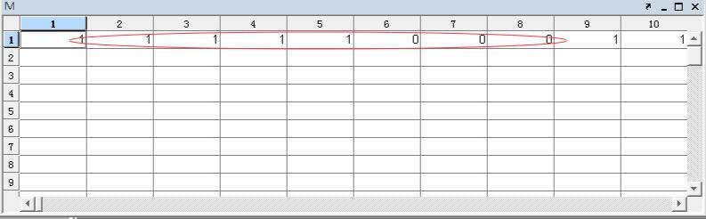

Fig. 6. The bit stream of secret information
According to human eye color seeing behavior we have 3 color matrix present with us these color matrix are Red, Green and Blue matrix. Our Human eye is most sensitive to green color then red and least sensitive to blue. So what we do here is do XOR or LSB of Green matrix and Control message and insert it in red matrix or blue matrix not in green matrix so that image occurs to be least changed. After that the least bit of Green is selected and after XOR with a bit of hidden text’s bit stream if result is 1 we replace the bits with that of red and if the result is somehow 0 we replace the bits with that of blue. Remember to replace in exact same position.

Figure 7 is to contrast the image after embedding the hidden information with the original image, its observed that human eye cannot tell the difference between the image with hidden information and the cover image. Furthermore, from the comparison of Figure 8, we can see that the histograms of them are basically the same.

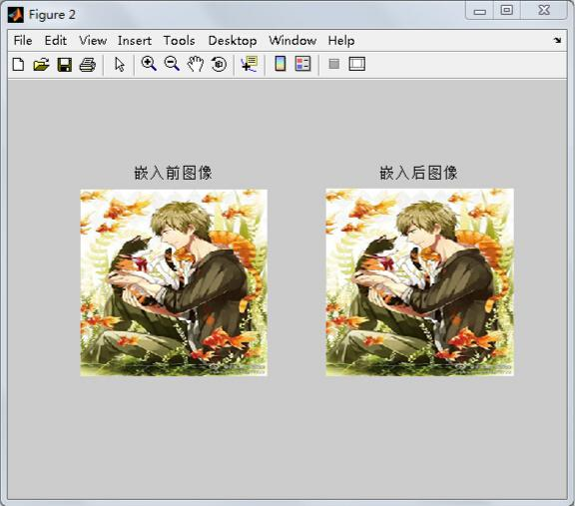
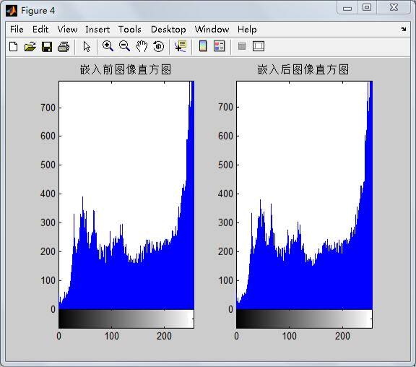
After the text is successfully embedded into the cover image we save the output file as “Initial Data Hidden Image”. Now the encryption phase is started which is applied on Initial Data Hidden Image. A key is required which should be of 8 bits to help in Encryption and Decryption by a genuine person. As shown in Fig 9.
Fig. 7. Image after embedding with original image
Fig 8. Histogram of images.

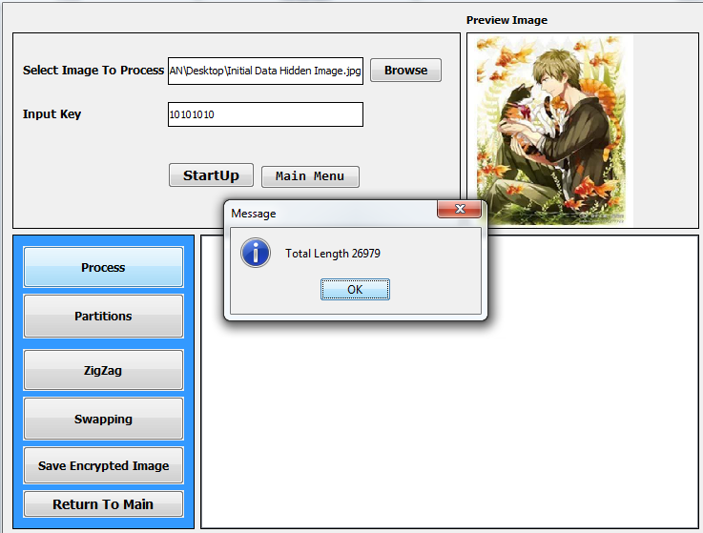
Fig 9. Inserting the Input Key and starting the process.

Before starting Partitioning it is ensured whether the image is converted into binary sequence or not only after which Partitioning, Zigzag and Swapping can be performed as shown in bellow.

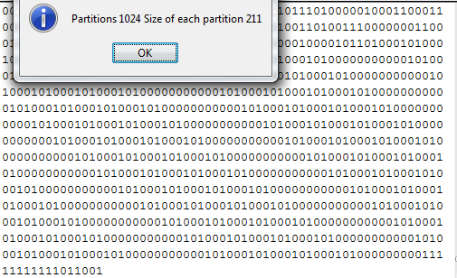

Fig 10. Partition has been performed.

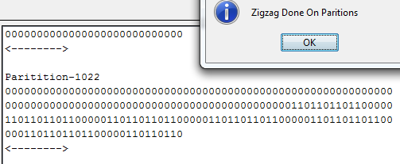
Fig 11. ZigZag has been performed.
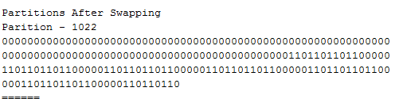

Fig 12. Swapping of the Partitions has been Performed

We then save new output file as “ newenc” this image can’t be viewed since we have applied all the encryption algorithms over it. Thus this approach makes the data as well as the cover image inaccessible to an intruder without a key and thus making it more secure. Newenc is the file that we will transfer to the intended user who can reverse the algorithms applied with the help of key to get the “Initial Data Hidden Image” which can be further used to extract the Hidden text. As shown in Fig 13.

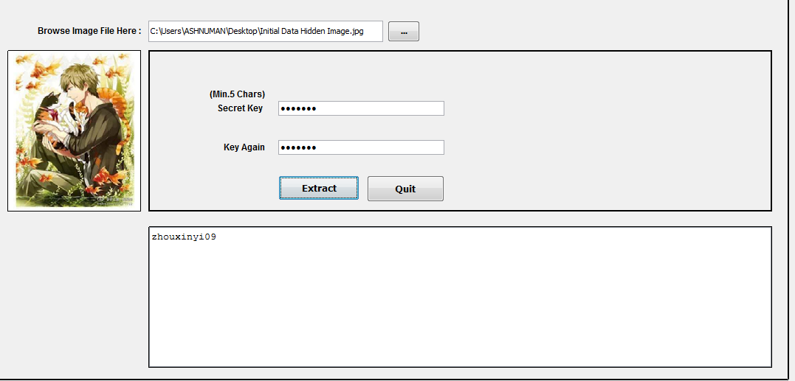
Fig 13. Getting the hidden text.

IV. RESULTS

We figure out two aspects that are PSNR and Security which determines that how our improved Steganography is better and an improved version when compared to the traditional approach.

A. PSRN

In the traditional approach of steganography we hide the data into an image by replacing its bit values with Red, Green and Blue color pixel values and calculate its PSNR and compare it with our approach in this paper the results are displayed in Table I.

TABLE I. COMPARISON PSNR WITH TRADITION LSB METHOD AND OUR LSB METHOD

Algorithms

PSNR | Red | Green | Blue | Ours
PSNR | 53.621 | 53.567 | 53.396 | 56.513

Higher the PSNR better the results are. Here we can clearly see that the PSNR of our approach is 3db higher than the traditional approach.

B. The Security

For our proposed method it can be seen that if an attacker gets the camouflage image (the encrypted image with hidden text) it would require a key to decrypt the image. Let us assume that by any means attacker is able to decrypt the cover image it’s still impossible to tell whether the cover image has any hidden information or not. Let’s assume that attacker knows that this cover image has any information hidden in it then also the location where it has been hidden is still unknown and would further require another key to perform the action. We have also added an identity authentication so that only intended sender and receiver will be able to use the process and thus removing the chances of forgery or imitation by others.

V. CONCLUSION

The “Hiding Data in Digital Image using Steganography and Applied Encryption” combines the traditional data hiding in images using LSB based algorithm for Steganography and various Cryptography algorithms to deliver one of the most secure way to hide information into an image and transfer it over internet or any other medium. This insures that only intended person is able to read the hidden text.
On one hand we set a key for Steganography where the cover image’s visual character is not at all altered and on the other hand we set another key and at the time of Encryption making the cover Image also inaccessible along with hidden text. Thus when this new cover image is transferred only a genuine intended user will be able to Decrypt the cover Image with key and further extract the hidden text with the help of key and reverse steganography. This method thus improves the security and prevents the forgery of hidden text making it a more powerful way to hide a data into image.
In future we can replace the encryption algorithms with new ones and use some algorithms other than LSB for Steganography but this would need more research in this field.

ACKNOWLEDGMENT

We would like to thank the key technology research of public digital culture sharing service; and SRM Institute of Science and Technology for its Engineering Project Program.

REFERENCES

- Zhang Yanling, Wang Yunfeng robustness analysis LSB image hiding algorithm [J] chaotic sequence enhanced Xi'an Technological University, 2015,10: 850-854.J. Clerk Maxwell, A Treatise on Electricity and Magnetism, 3rd ed., vol. 2. Oxford: Clarendon, 1892, pp.68-73.

- Yan Xiaomeng Zhang Tao, Xi Ling, PING Xi build one for LSB matching steganography load new positioning algorithm [J] data acquisition and processing, 2016,01: 145-151.K. Elissa, “Title of paper if known,” unpublished.

- S. M. Masud Karim, M. S. Rahman and M. I. Hossain, "A new approach for LSB based image steganography using secret key," Computer and Information Technology (ICCIT), 2011 14th International Conference on, Dhaka, 2011, pp. 286-291.

- Stefan Katzenbeisser, Fabien AP.Petitcolas (a), the new Charles Ng, NIU Xin-xin, xian, etc. (translation) information hiding - steganography and digital watermarking [M] Beijing: People's Posts and Telecommunications Press, 2001,50-62.

- Huang Jian .RSA safety analysis and improvement of public key encryption system [J] computer and network, 2016,01: 70-73.

- Paragraph Hongying, Shaoze Yun, Cao Jianying RSA digital signature technology and safety research [J] Longdong College, 2015,01: 38-40.

- Zhang Haitao, YEW Suet, Chen Hongyu, Zhang Ye bit planes and HVS information hiding algorithm [J]. Chinese Journal of Image and Graphics, 2013,12: 1559-1566.

- Li Li. Study [D] based on the LSB information hiding technology, Beijing University of Posts and Telecommunications, 2011.

- Yang Zhenya, Wang Yong, vector Yang Zhendong, Wang Tao RGB color space - from the perspective of color difference formula [J]. Computer Engineering and Applications, 2010,06: 154-156.

